**Submission Instructions:**

Your submission for this activity should be a Word document that includes the following screenshots, each labeled for the step that the screenshot represents:

1. Provide a screenshot to show that you successfully created the data folder and downloaded the departuredelays.csv file.

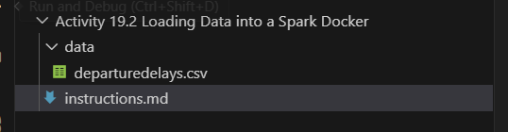

1. Provide a screenshot to show that the Spark Docker *containers* that you created in Activity 19.1 are running.

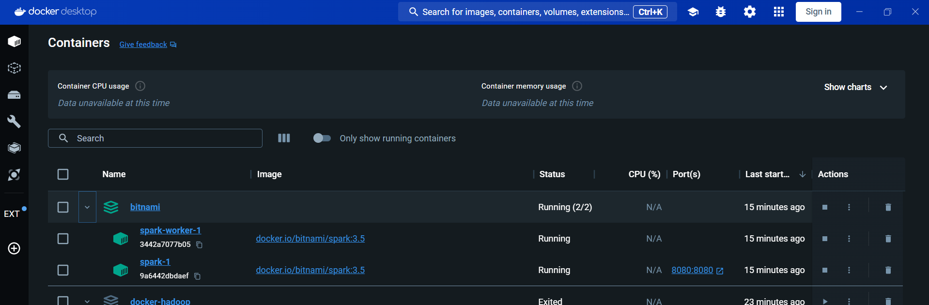

1. Provide a screenshot to show that you successfully ran the docker cp command to copy the departuredelays.csv file to the Spark Docker *container’s* root folder.

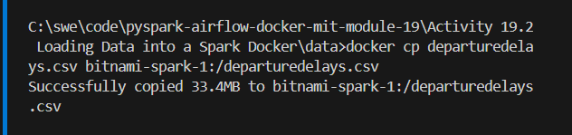

1. Provide a screenshot to show that the departuredelays.csv file has been copied to the root folder.

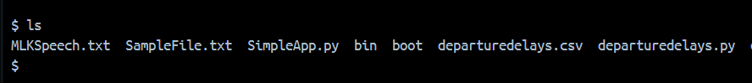

1. Provide a screenshot to show that you successfully started the PySpark interface.

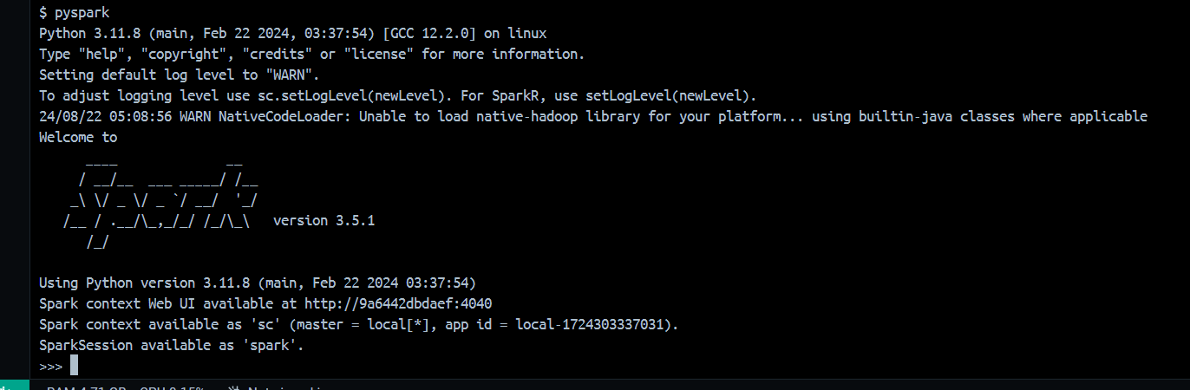

1. Provide a screenshot to show that you successfully ran the command to create a Spark session.

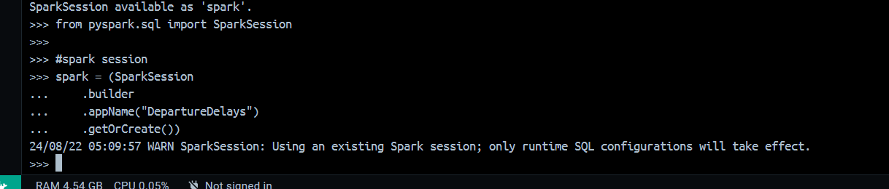

1. Provide a screenshot to show that you successfully ran the command to load the departuredelays.csv file into a Python *dataframe*.

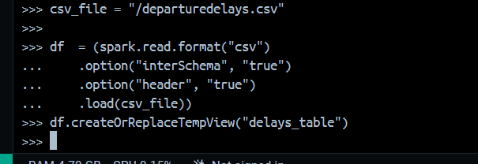

1. Provide a screenshot to show that you successfully ran the SQL *query* and selected the correct columns (distance, origin, and destination).

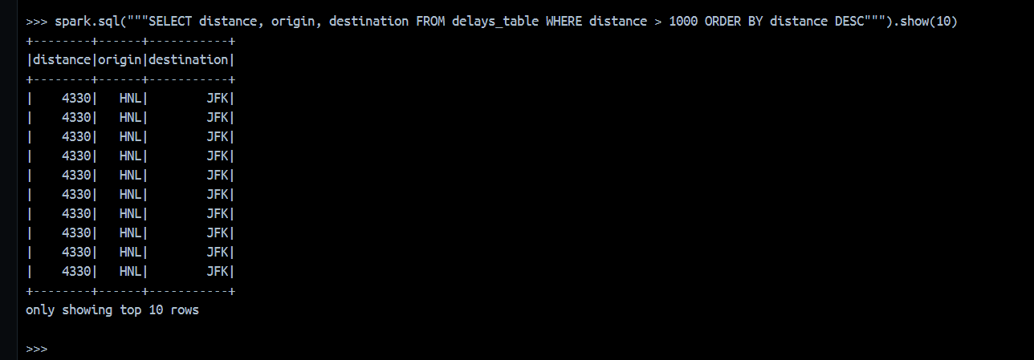

1. Provide a screenshot to show that you successfully ran the SQL *query* with the correct rows.

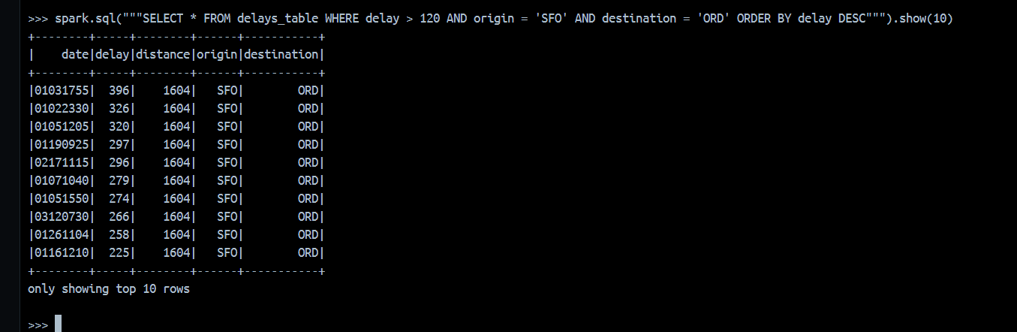

1. Provide a screenshot to show that you successfully ran the SQL *query*, categorized the data correctly, selected the correct columns, and showed 10 rows of data.

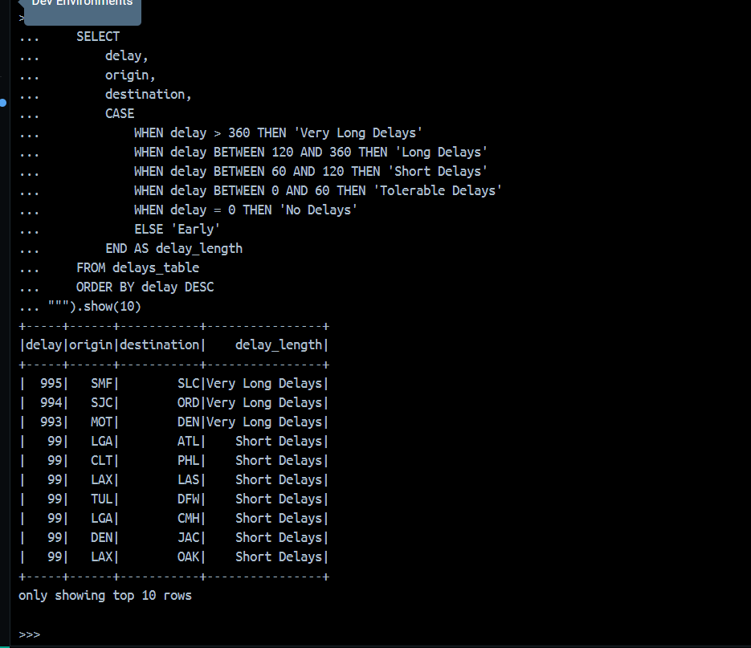

1. Provide a screenshot to show that you successfully ran the *query* to determine the correct maximum delay for all of the flights in the dataset.

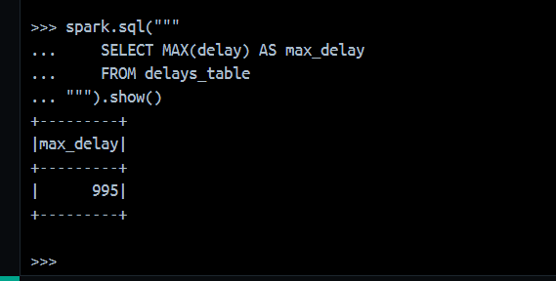

1. Provide a screenshot to show that you successfully ran the *query* to determine the correct minimum delay for all of the flights in the dataset.

